**EXERCISE 1a: Memory recall UI**

**Aim:**

To design a UI where users recall visual elements (e.g., icons or text chunks) and evaluate the effect of chunking on user memory.

**Procedure:**

**A. Home Screen:**

1. **Create a Frame** (1024x768px for desktop).
2. **Add Instructions**: Use text for headings and detailed instructions.
3. **Start Button**: Create a button with text "Start" and link it to the next screen (Chunking Phase).

**B. Chunking Phase:**

1. **Create a New Frame** for the Chunking Phase.
2. **Design Chunked Items**: Group 3-5 items (icons/text) into chunks (with or without borders).
3. **Set Viewing Time**: Simulate time by setting a 5-second transition to the next screen.

**C. Recall Phase:**

1. **Create a New Frame** for recall.
2. **Recall Input**: Use either multiple-choice (checkboxes/radio buttons) or text input fields for users to recall items.
3. **Submit Button**: Create a "Submit Recall" button and link it to the next screen (Feedback).

**D. Result Screen:**

1. **Feedback Screen**: Display recall accuracy (e.g., “You recalled 4/5 items correctly!”).
2. **Analyze**: Vary chunk size (3 vs. 5 items) and chunk type (icons vs. text) for testing.

**Output:**

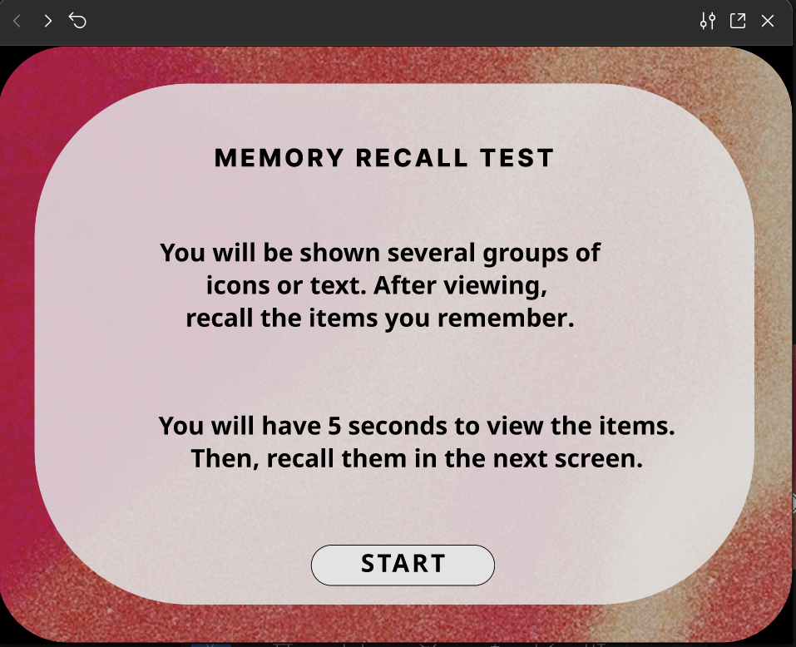

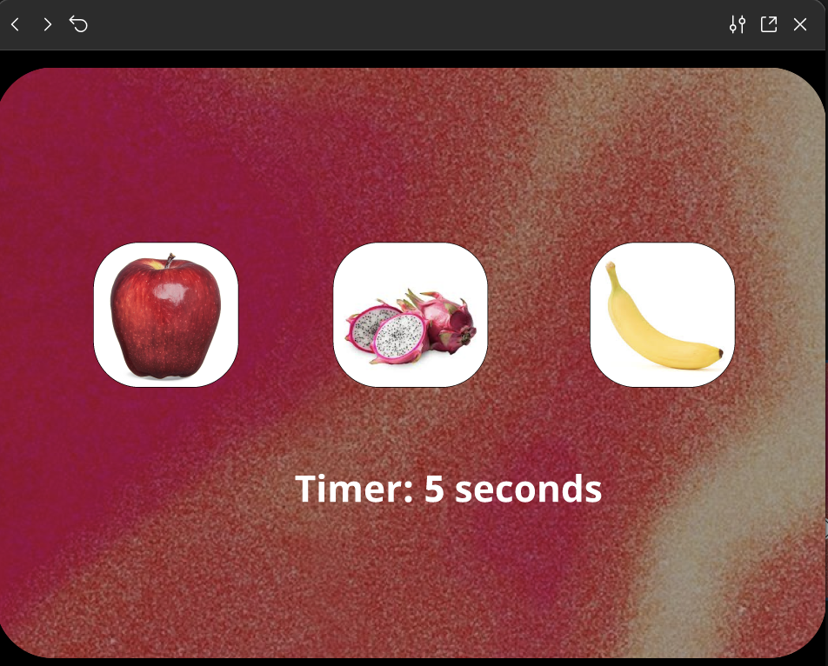

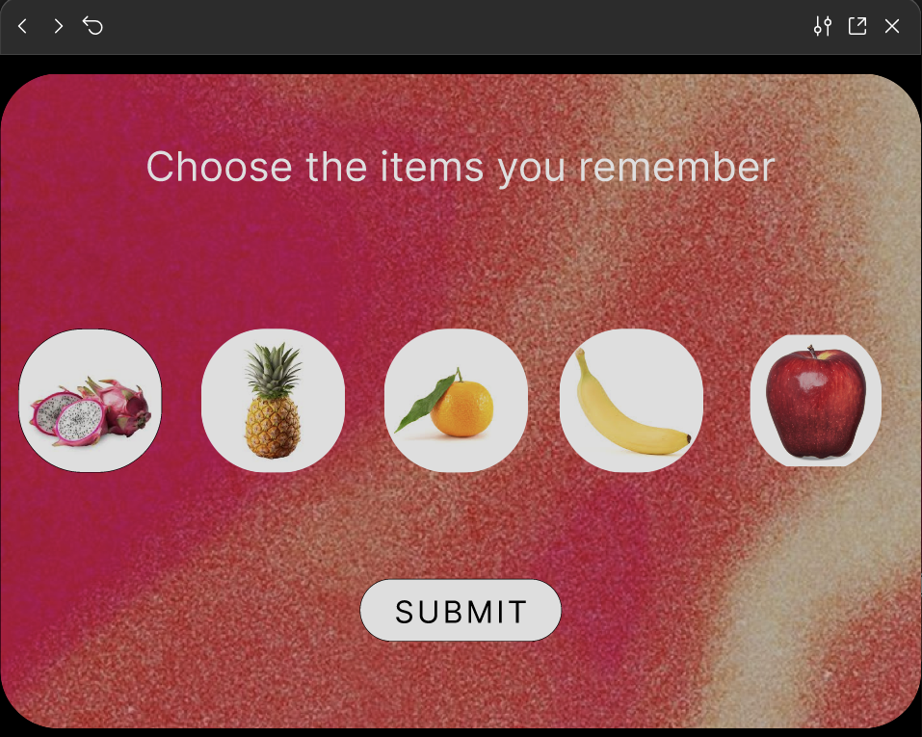

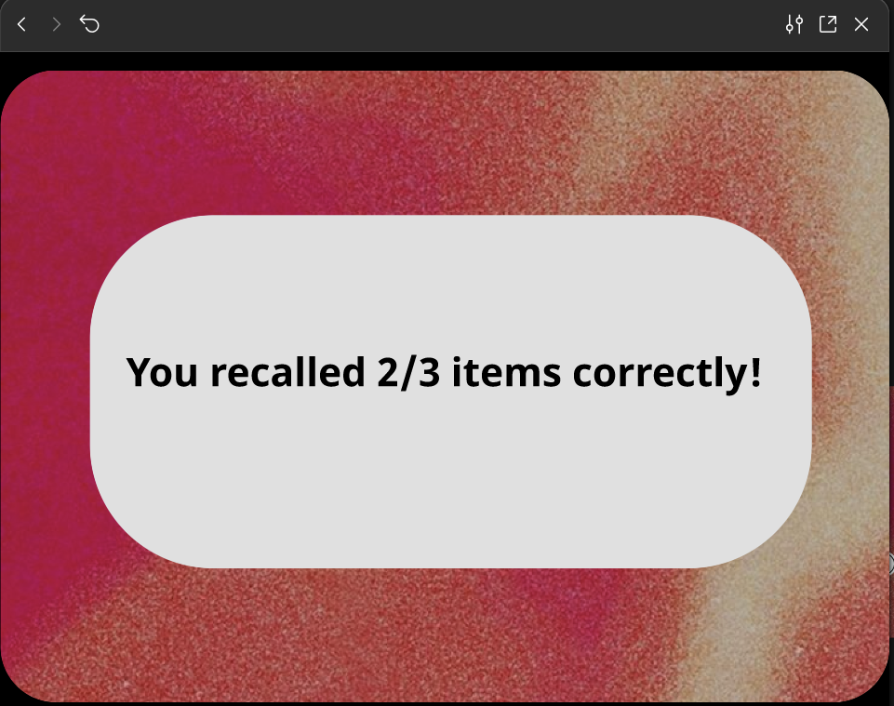

**LINK:**

**https://www.figma.com/proto/8tQTaum1Ose8M70q5FYkoV/Untitled?node-id=1-2&t=SZnpx7mkYL9AatVN-1&scaling=min-zoom&content-scaling=fixed&page-id=0%3A1&starting-point-node-id=1%3A2**

**Result:**

The **Memory Recall UI** successfully tests chunking effects by displaying grouped icons/text, prompting recall, and providing feedback on user memory accuracy.